Cultural Event frequency

Forcing by solar activity, relationship with temperature

Other relevant cycles

Cross correlation between time series

**Data**:

Frequency of Events in the last 2000 years.

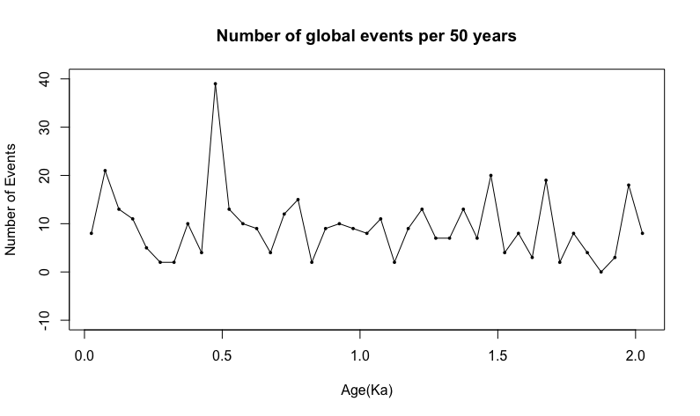

Frequency of Events in the last 5000 years and then for the whole Holocene epoch. But events are clustered in the nearest thousands like (3Ka, 4Ka, 5Ka) which are misleading.

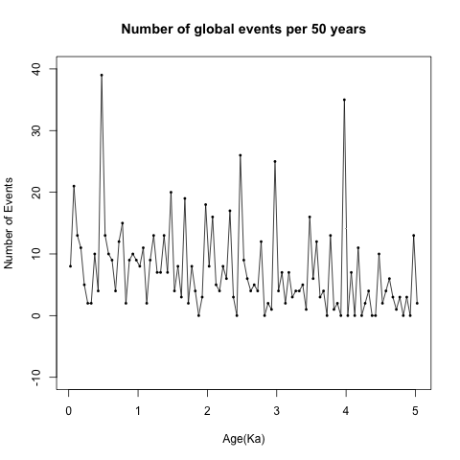 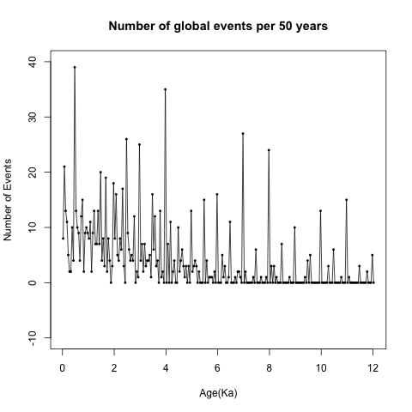

Analysis on the event frequency data from last 2000 years.

Data Processing: Convert the non-stationary event number time series to a weak stationary time series(mean and autocovariance does not change with time) to further do cycle analysis.

1. Demean
2. Filtering with Hanning moving average
3. Detrending (residuals from linear regression)
4. Tapering
5. Hanning smoothing of power spectra

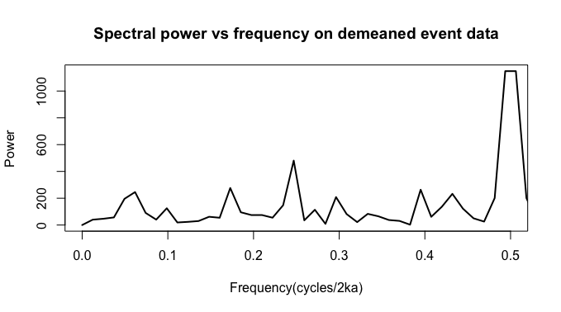

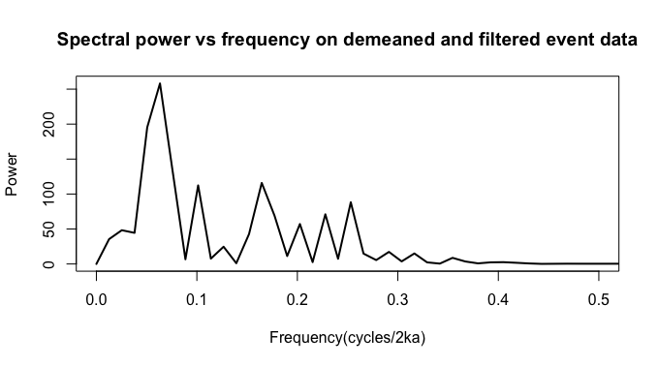

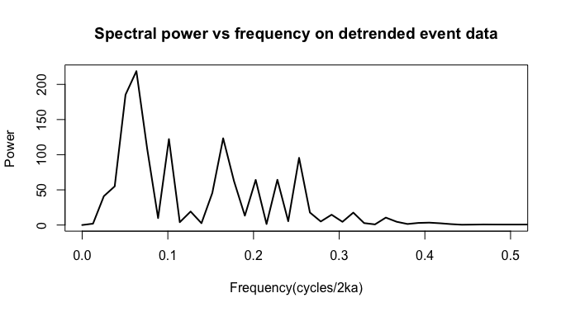

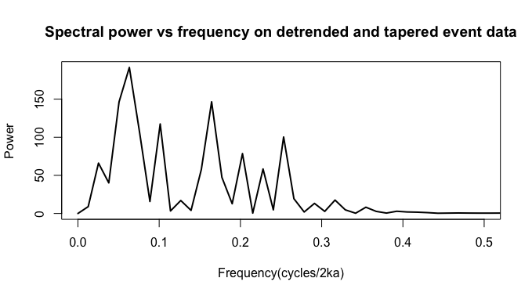

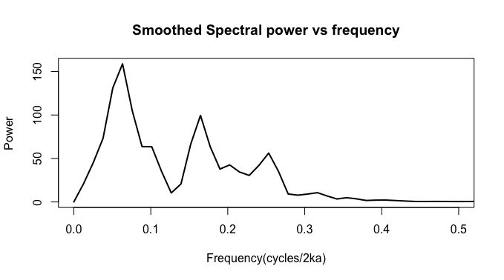

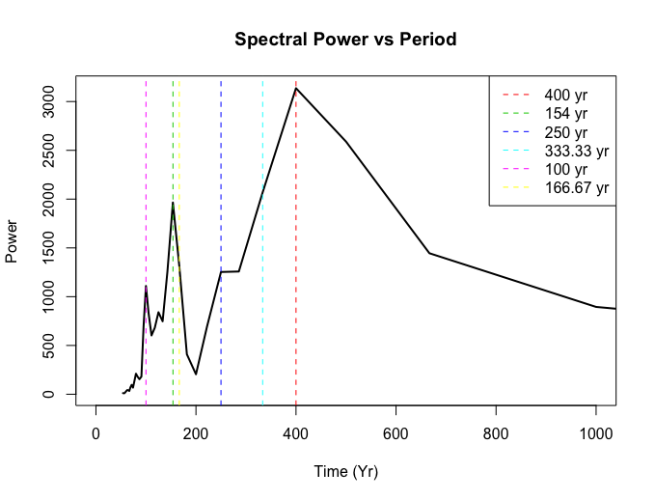

|  |  |  |  |  |
| --- | --- | --- | --- | --- |
| **# Cycles** | **Frequency** | **Period** | **Amplitude** | **Power** |
| 6 | 0.06329114 | 400.0000 | 122.99625 | 158.83075 |
| 14 | 0.16455696 | 153.8462 | 107.57012 | 99.50760 |
| 5 | 0.05063291 | 500.0000 | 107.54739 | 131.11470 |
| 9 | 0.10126582 | 250.0000 | 96.29151 | 63.44699 |
| 7 | 0.07594937 | 333.3333 | 91.47636 | 104.76960 |
| 21 | 0.25316456 | 100.0000 | 89.00611 | 56.19316 |
| 17 | 0.20253165 | 125.0000 | 78.75561 | 42.57242 |
| 3 | 0.02531646 | 1000.0000 | 72.24159 | 45.31505 |
| 19 | 0.22784810 | 111.1111 | 67.90576 | 30.50830 |
| 13 | 0.15189873 | 166.6667 | 67.54380 | 66.50646 |

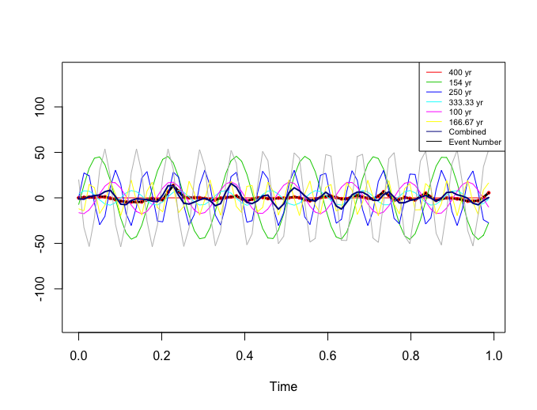

Events in Africa during last 2 thousand years.



Events in the region of East Asia and Oceania during last 2 thousand years.

tscreator_output/Global_event_numbers_50_yr_bin_East_Asia_Oceania_from_0_to2ka.pdf

Events in Middle eastern and Indian region during last 2 thousand years. However, the Indian region events are missing many details of the history of Indian subcontinent.

tscreator_output/Global_event_numbers_50_yr_bin_Middle_East_India_from_0_to2ka.pdf

Events in the region of East Asia and Oceania during last 2 thousand years.

**tscreator_output/Global_event_numbers_50_yr_bin_East_Asia_Oceania_from_0_to2ka.pdf**

Events in European region during last 2 thousand years.

tscreator_output/Global_event_numbers_50_yr_bin_Eastern_Mediterranean_from_0_to2ka.pdf

**Left**: Events in Arctic and Sub-arctic regions during last 2 thousand years. **Right**: Events in Northwest and Canada during last 2 thousand years.

tscreator_output/Global_event_numbers_50_yr_bin_Arctic_Subarctic_from_0_to2ka.pdf tscreator_output/Global_event_numbers_50_yr_bin_Northwest_Canada_from_0_to2ka.pdf

Events in North American region during last 2 thousand years.

tscreator_output/Global_event_numbers_50_yr_bin_North_America_from_0_to2ka.pdf

Events in Middle and South American region during last 2 thousand years.

tscreator_output/Global_event_numbers_50_yr_bin_Middle_South_America_from_0_to2ka.pdf